Assessment: Lab7

Student Name: Zahi Masarwa

Lab Professor Name: Mel Sanschagrin

Lab Section Number: 303

Due Date: 02/28/21

# Part 1: Pseudocode and Flowchart (updated versions)

start

declarations

EpsilonTester epsilonTester

num CONTINUE_PROGRAM = 1

num continueProgram = 0

text report

num choice

do{

epsilonTester.interactWithUserForFieldValues()

report = epsilonTester.compareWithEquality()

output report

report = epsilonTester.compareWithEpsilon()

output report

output "Program by Your Name"

output “Choose 1 to contenue test numbers”

output “Choose 0 to exit program”

input choice

while (choice <> CONTINUE_PROGRAM and choice<> continueProgram){

output “number that enterned is incorrect please enter again”

input choice

}

}while (choice <> continueProgram)

output "Program has existed"

stop

# Flowchart

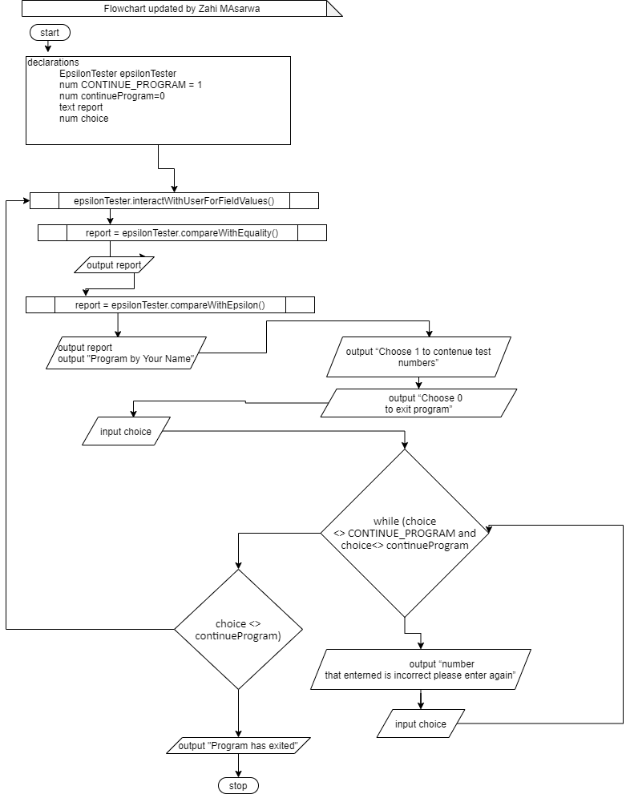

# Algorithm test plan

|  |  |  |  |
| --- | --- | --- | --- |
| continueProgram | CONTINUE_PROGRAM | Program Action | Description |
| 1 | 1 | Program continues | Program continues loop. |
| 0 | 1 | Program exists | The program will exit the loop |

# Java Screen Shot

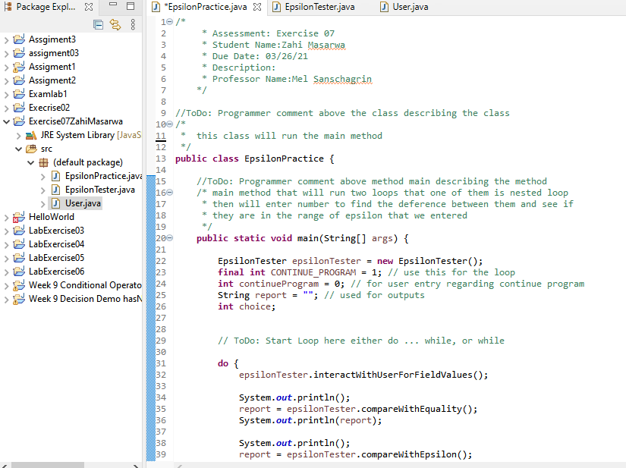

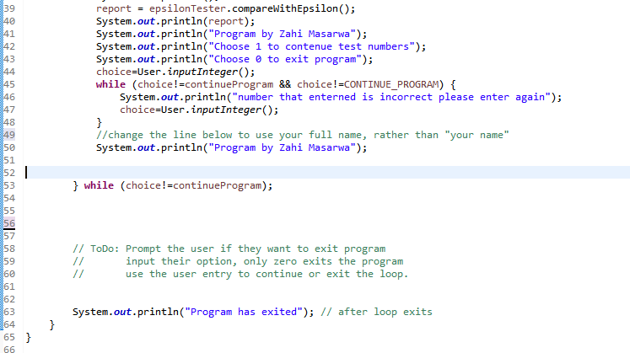

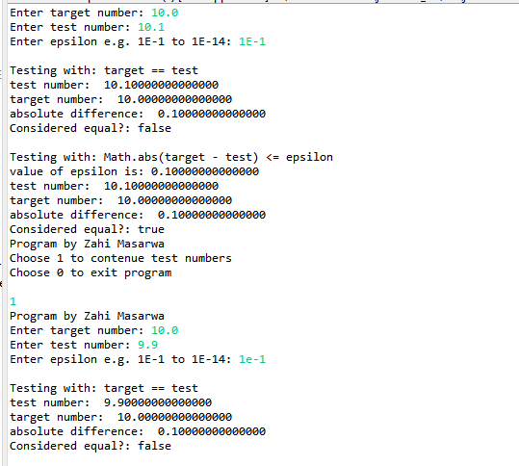

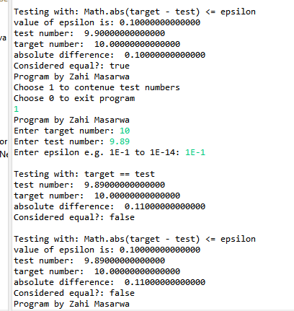

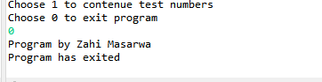

# Test Your Program

|  |  |  |  |  |
| --- | --- | --- | --- | --- |
| continueProgram | CONTINUE_PROGRAM | Inputs | Outputs | Description |
| 1 | 1 | 10.0  10.0  1E-1 | arget == test  test: 10.00000000000000  target: 10.00000000000000  difference: 0.00000000000000  result: true  Math.abs(target – test) <= epsilon  epsilon: 0.10000000000000  test: 10.000000000  00000  target: 10.00000000000000  difference: 0.00000000000000  result: true |  |
| 1 | 1 | 10.0  10.1  1E-1 | target == test  test: 10.10000000000000  target: 10.00000000000000  difference: 0.10000000000000  result: false  Math.abs(target – test) <= epsilon  epsilon: 0.10000000000000  test: 10.10000000000000  target: 10.00000000000000  difference: 0.10000000000000  result: true |  |
| 1 | 1 | 10.0  9.9  1E-1 | target == test  test: 9.90000000000000  target: 10.00000000000000  difference: 0.10000000000000  result: false  Math.abs(target – test) <= epsilon  epsilon: 0.10000000000000  test: 10.10000000000000  target: 10.00000000000000  difference: 0.10000000000000  result: true |  |
| 1 | 1 | 10.0  9.89  1E-1 | target == test  test: 9.89000000000000  target: 10.00000000000000  difference: 0.11000000000000  result: false  Math.abs(target – test) <= epsilon  epsilon: 0.11000000000000  test: 9.89000000000000  target: 10.00000000000000  difference: 0.11000000000000  result: false |  |
| 1 | 1 | 10.0  10.11  1E-1 | target == test  test: 10.11 000000000000  target: 10.00000000000000  difference: 0.11000000000000  result: false  Math.abs(target – test) <= epsilon  epsilon: 0.11000000000000  test: 9.89000000000000  target: 10.00000000000000  difference: 0.11000000000000  result: false |  |